The PE starter describes the acoustic field at source location, so, if we use a starter in the shape of one mode instead of a point source, we can study the mode coupling effects in the propagation. If the sound speed profile is range-independent, there shall be no energy exchange, i.e., adiabatic propagation; otherwise, the modal energy will be coupled into higher or lower modes at various degrees.

Mathematically, since the PE envelope function can be decomposed into weighted summation of different modes, , the starter field at is , and we can suppress other modes to generate a modal starter as (omitting the constant ) .



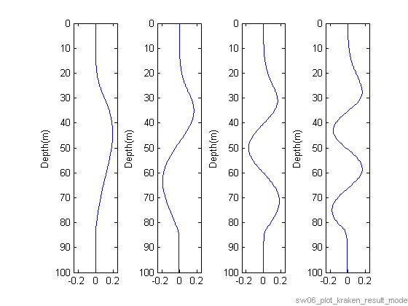

Fig 1. From left to right, vertical modes 1-4 excited by a 330Hz frequency signal. Temperature data were recorded at NRL300 source, GMT21:30, Aug 17, 2006.

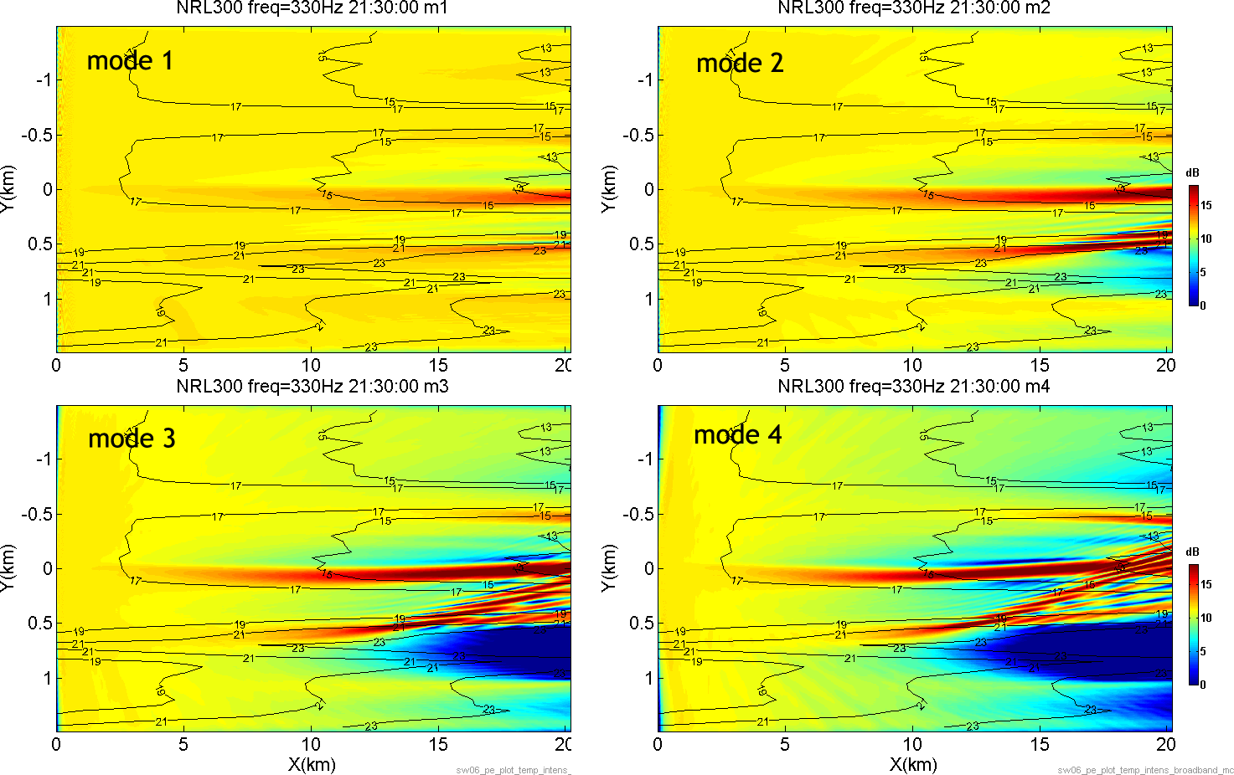

Fig 2. Acoustic intensity is shown for vertical modes 1~4. A single frequency signal (330Hz) source is placed at (0,0), depth = 70m. Temperature contour overlay shows the passing internal waves.

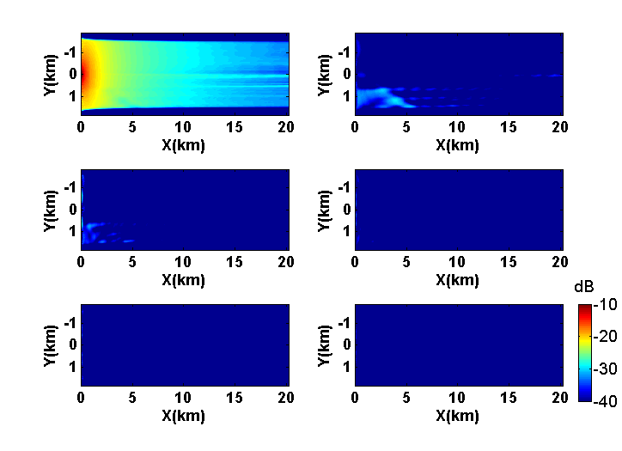

Fig 3(a). Energy transfer from mode 1 to other modes due to mode coupling. 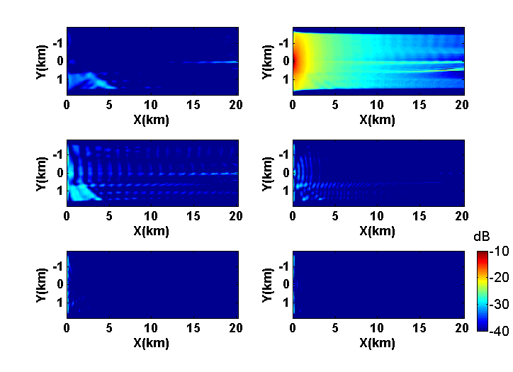

Fig 3(b). Energy transfer from mode 2 to other modes due to mode coupling.

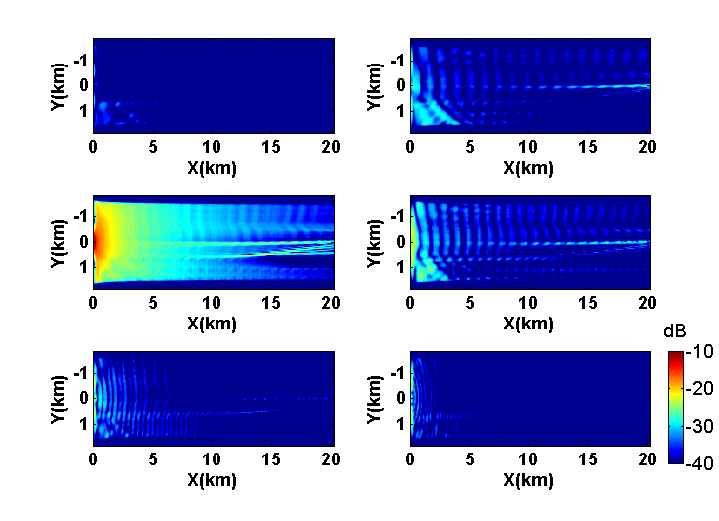

Fig 3(c). Energy transfer from mode 3 to other modes due to mode coupling.

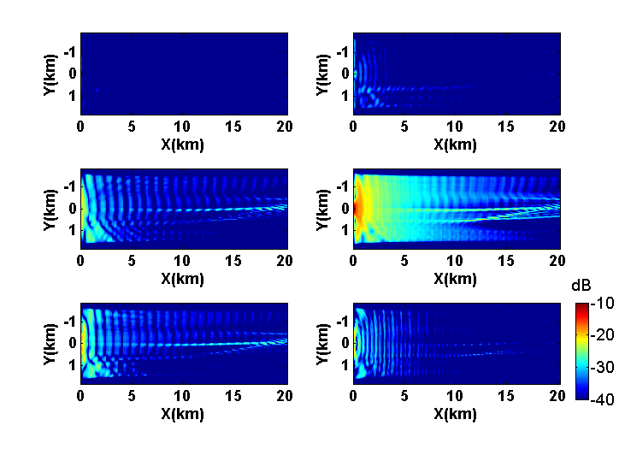

Fig 3(d). Energy transfer from mode 4 to other modes due to mode coupling.

Remarks about mode coupling: 1) most energy is confined at the excited mode at the source, which is consistent with the theory about adiabatic propagation at near-parallel environment. 2) Higher modes show stronger coupling effects than lower modes. Energy from mode 1 will couple to mode 3, while mode 4 can couple up to mode 8.

